User Management documentation

1. User session

To access user session, we access via session array key is table name. You can use constant instant “USERS” of table name

Example:

$this->session->userdata(USERS);

It will return an array as:

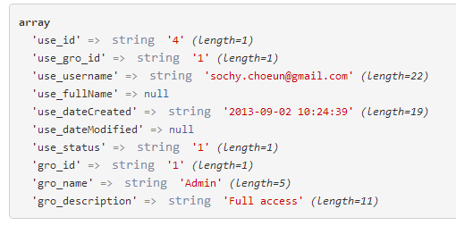

1. Allow permission
2. ---